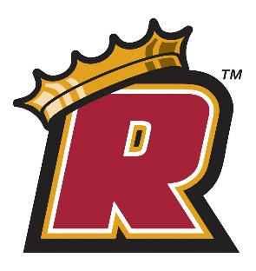
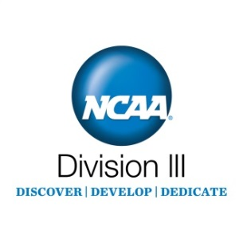

NCAA Division III Student-Athlete
Celebratory Signing Form

I, have been accepted to Regis, A Catholic University in Greater Boston, an NCAA Division III institution. In addition to my academic responsibilities, I intend to participate in the sport(s) of during the 2018-2019 academic year.

Consistent with Division III's goal of fostering an environment where students can follow their passions and discover their potential, Division III student-athletes are encouraged to:

DISCOVER
Division III student-athletes are encouraged to pursue their interests and passions beyond the classroom and field of play…to discover themselves.

DEVELOP
Division III institutions provide an environment that encourages student-athletes to develop into well-rounded adults. Small class sizes, the ability to participate in more than one sport, and
an emphasis on participating in activities outside of the classroom are all
hallmarks of the Division III experience.

DEDICATE
Division III institutions expect student-athletes to dedicate themselves to achieving their potential. Student-athletes must manage their busy schedules, keep up with class work and face the same challenges as the rest of the student-body.

REGIS MISSION STATEMENT
Regis College, through education in the arts, sciences, and professions, empowers women and men to challenge themselves academically, to serve and to lead. A Catholic college, Regis is a diverse and welcoming community guided by the values of the Sisters of St. Joseph of Boston.

This form commemorates my choice to attend Regis, A Catholic University in Greater Boston. By signing this form, I embrace the Division III philosophy. I also understand my signature neither obligates me to attend the institution, noted above, and participate in athletics nor does it guarantee me a roster position.

Prospective Student-Athlete: ___________________________________ Date: __________________

