
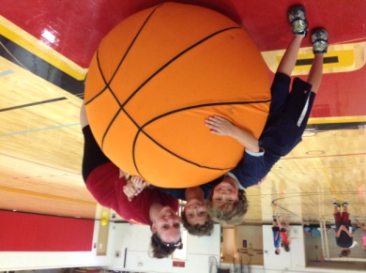

VACATION PLAY DAYS AT REGIS COLLEGE

(We only take the first 60 children so REGISTER EARLY!)

“COME ENJOY OUR POOL, SPORTS GAMES, ARTS & CRAFTS & MORE”
Daily Schedule
8:00 Free Play
8:30 Attendance
8:45 Pool Games
9:45 Snack
10:00 Sports games
10:30 Scooter games
11:00 Arts & Crafts
11:30 Lunch & Movie
12:30 Free Play
1:00 Rec Games
1:30 Group games
2:00 Free Swim
3:00 Pick-Up

When: April 15th - 18th
Where: Regis College Athletic Facility


Time: 8:00am-3pm
Ages: 5-12years old

Cost: $195.00 per week

REGISTER TODAY
APRIL VACATION PLAY DAYS

Name: __________________________________________Age: __________________
Address: _______________________________________________________________
City: ____________________________ State: ______________ Zip code: _________
Phone Number: _______________________Emergency Number: _______________
Email Address: _________________________________________________________
(Please make check payable to Regis College)

PARTICIPATION WAIVER FORM

Parent’s name: __________________________, the legal guardian of child’s name: _____________________ authorize Regis College and all those associated with the Regis College to administer general first aid treatment for any minor injuries received by my child during the Vacation play days. If the injury sustained is life threatening or needs emergency treatment, I authorize Regis College or their representatives to summon any or all professional personnel to attend to, transport, or treat my child. If the injury sustained requires hospitalization, I understand that my medical insurance company or I is solely responsible for all bills and claims that may be filed as a result of the injury. By signing this medical release form, I further understand that I will not file any civil liability lawsuit against Regis College or their representatives as a result of any injury sustained by my child during the Vacation Play Days.

Parent Signature: _____________________________________________________Date: ___________________

